Name
Tutor Name
Course
Name

- (10 pts) For the following set of sample data:
x = {2, 4, 1, 1, 3, 0, 5}

- calculate the mean, median, and mode

mean=$\frac{\sum{x}}{n}$ (2+4+1+1+3+0+5)=16/7 =2.29

Median=middle of the data when data set is ordered
(0,1,1,2,3,4,5) = 2
Mode= Greatest frequency 1 with frequency of 2
- Calculate the standard deviation using the deviation scores method

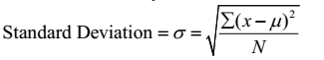
Score
2 | 2-2.29=-0.29 | 0.0841
4 | 4-2.29=1.71 | 2.9241
1 | 1-2.29=-1.29 | 1.6641
1 | 1-2.29=-1.29 | 1.6641
0 | 0-2.29=-2.29 | 5.2441
5 | 5-2.29=-2.29 | 5.2441
 |  | 16.8246

$\sqrt{\frac{16.8246}{7-1}}$ =1.6745
C) Calculate the standard deviation using the raw scores method and confirm the same answer as for part b.
=$\sqrt{\frac{16.8246}{7}}$ =1.55
The standard deviation under raw score method is lower than that of score standard deviation
- Calculate the variance.
$σ2$=1.6745²=2.804

- (12 pts) For the following data x: {5, 2, 7, 9, 4}
- Find SS
(5+2+7+9+4)=27/5
=5.4
Score
5 | 5-5.4=0.4 | 0.16
2 | 2-5.4=-3.4 | 11.56
7 | 7-5.4=1.6 | 2.56
9 | 9-5.4=3.6 | 12.96
4 | 4-5.4=-1.4 | 1.96
 | SS | 29.2
b. Find s

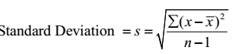
$\sqrt{\frac{SS}{n-1}}$= $\sqrt{\frac{29.2}{5-1}}$ =2.702
- Find σ (assuming this is population data):
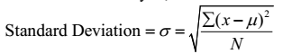
$\sqrt{\frac{SS}{N}}$= $\sqrt{\frac{29.2}{5}}$= 2.4166

d. Assuming this is population data, calculate SS/N. What is the name we give to this statistic?

$\frac{SS}{N}$=29.2/5 =5.84
$$this is called the varience of the population$$
3. | (5 points) The deviation-method formula calculating the standard deviation (and variance) includes the mean. Explain why it makes sense for this measure of the variability of a sample to be calculated using the mean. (Hint: what is it that the standard deviation measures?).  The standard deviation measures the variability and consistency of sample and population  The value measure how the values are spread from the mean  - (10 points) For the following questions, assume a normal distribution with a Mean (M) of 50, and a standard deviation (SD) of 5. Convert each of the following scores to a z-score on this distribution  $$z=\frac{x-u}{σ}$$
- 30 = (30-50)/5=-4
f. 47 = (47-50)/5=-0.6
g. 59 = (59-50)/5=2.25
- 62 = (62-50)/5=12
I. 10 = (10-50)/5=-8
J. 38 = (38-50)/5=-2.
- 45 = (45-50)/5=-1
- 40 = (40-50)/5=-2
- 20 = (20-50)/5=-6
- 29 = (29-50)/5=-4.2

- 10 points) For the following questions, assume a normal distribution with a Mean (M) of 20, and a variance of 16. Convert each of the following z-scores to a raw score on this distribution:
e. 5 = (0.5*4+20) =22
f. 3 =(3*4+20)= 32
g. 1.15 = (1.15*4+20) =24.6
h. -4 =(-4*4+20) = 4
i. -3.8 = (-3.8*4+20) = 4.8
j. 2.7 = (2.7*4+20) = 30

$z=\frac{x-u}{σ}$ Z$σ$+U=X
a. 1 = (1*4+20)=24
b. -2 =(-2*4+20)=12
c. -2.4 =(-2.4*4+20)=10.4
d. 0 = (0*4+20)=20

- From the two curve although the dotted line has the highest mean score of 75 it has the highest standard distribution from the normal therefore the block line which has a lower mean of 70 has the smallest standard deviation, therefore, the best school to choose for the kid

6. | (18 pts) A researcher who is interested in the effect of price on perceived quality gives a group of 50 students sneakers which are described to them as “expensive”, while another group of 50 students receives the very same sneakers which are described to them as “discount.” The students are then to rate the perceived quality of the sneakers on a scale using only one of the following values (0=poor quality, 1=satisfactory quality, 2=good quality, 3=very good quality, 4=superior quality) to see if there is a difference based on price description.  - What is the independent variable?  The “expensive” and “discount” are the independent variable since the rate depends on the quality of the sneakers  - What is the dependent variable?  The dependent variable is the rate with depend on the quality of sneaker for rating

- Is the dependent variable discrete or continuous?
The variables are discrete since the results can only be given using the natural numbers
- What scale of measurement (nominal, ordinal, interval or ratio) is used to measure the dependent variable?
The number are ordinal since they show the rank of the rating by the student
- What research method is being used (experimental or observational), and why
The research method being used is the experimental method since the uses the results from a student who give their rating and not the researcher rating if it was the observation the researcher will be the one who could have given the result
- If, instead of measuring the perceived quality of shoes, the researcher decides to measure the distance each individual can jump off of the ground (in centimeters), which of the above answers changes? And what is/are the new answer(s)?
C will change to be continuous since the values obtained will have interval values
D will change to interval value
E will change to observation since the value recorded will be obtained by researcher by observing
- (16 pts) The first exam grades of last semester’s Stats class had a mean of 67 with a standard deviation of 5 points. Answer the following questions:
- Jenny received a score of 80. What is her z-score? Is it positive or negative? Why?

$$z=\frac{x-u}{σ}$$
Z=$\frac{80-67}{5}$ =2.6
- Michael’s z-score was a -1.5. Did he do better or worse than the average? How can you tell? And by how many points?
Z$σ$+U=X
=(5*-1.5+67) =59.5
The scores were lower than the mean score , therefore,the scores were worse
- Anne’s z-score was a 0. What does this tell you about her score in relation to the mean?
Z$σ$+U=X
(0*4+67) =67
When the z-score is o the it means that the score lie on the mean value
- John received a score of 65. What is his z-score? Is it positive or negative? Why

The z-score are negative since John Score lie below the mean
- Which (if any) students fall into the middle 68% of the distribution?
Anne and john with grade of 67 and John
- Which (if any) students fall outside of the middle 68% of the distribution?
Michael and Jenny since their Z-score are greater than +-1
- Which (if any) students fall into the bottom 5% of the distribution?
Jenny since the z-sores are greater than 2
d
- (10 pts) SPSS: For the following data:
x={3, 4, 7, 6, 5, 1, 4, 3, 4, 4, 5, 4, 0, 3, 5, 4, 4, 4}
- Use SPSS to find the Mean, Median, Mode and Standard Deviation. Paste your output:
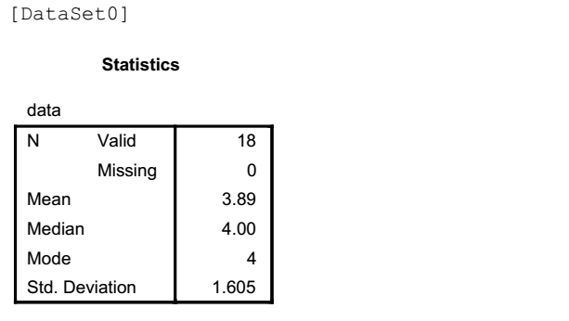

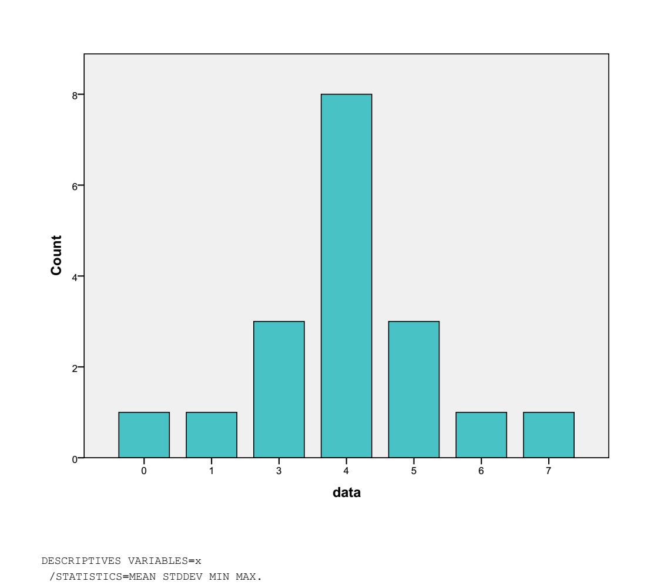
- Construct a frequency histogram of this data, with a discrete x-axis that starts at 0 and ends with 7. Paste below:
- Describe the distribution (modes, skew, etc) and indicate how the relationship between the mean and median also reflects the observation you have made
From the histogram above the data has mode of 4 since it has the highest frequency 8 the data is also evenly distributed around the mean meaning that the skew is never positive or negative

The mean mode and mode are around the 4 score meaning the data series is normally distributed
- Using SPSS, convert each score in this distribution into a z-score. Then construct a frequency histogram of the z-scores (x-axis should span from -3 to 2, because you should not have any z-score values outside of this range). Paste below:
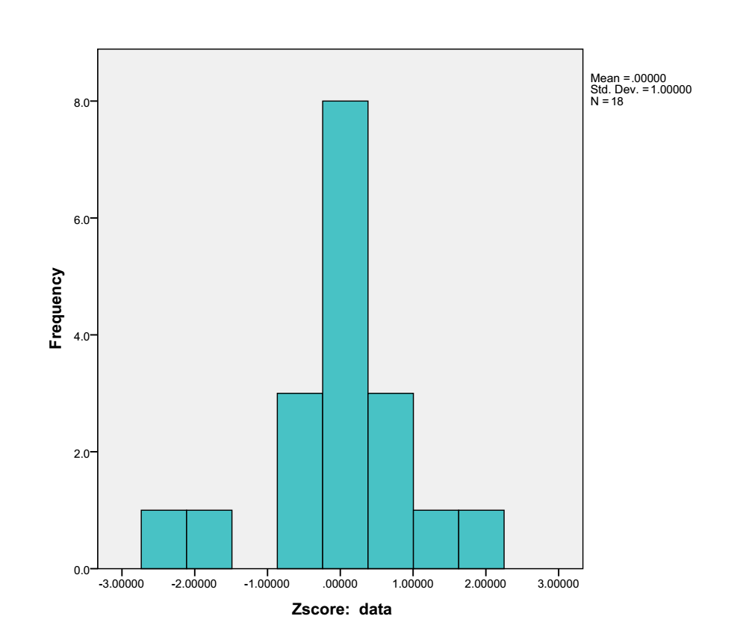
- Describe the similarities between the raw-score histogram you created and the z-score histogram. What are the differences, if there are any?
The two histogram form a normal curve with the highest point where the mean mode and median lies.

- (4 pts) SPSS: For the following set of January 2014 temperature (in Fahrenheit) data:
x = {26, 45, 31, 28, 52, 7, 40, 34}
Find the mean, median, mode, range, standard deviation, and variance in SPSS. Paste below ONE table which contains all of the above statistics. Indicate the steps you took to construct this table.
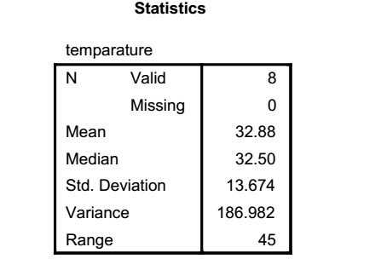
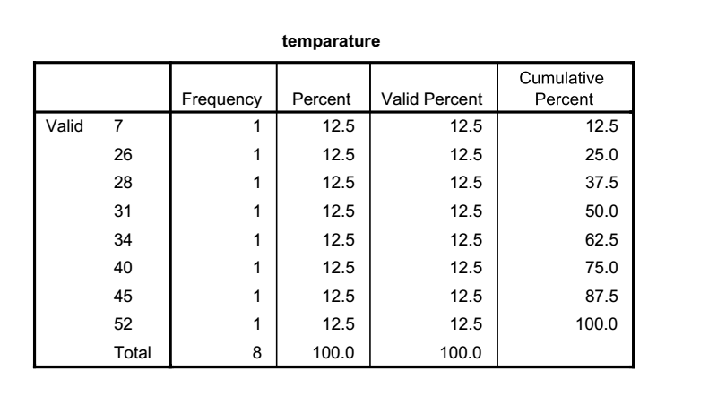

- Input data in the data view mode
- Click Analyze > Descriptive Statistics > frequencies
- Double click on the variables temperature in the left column to move them to the Variables box.
- Click OK when finished

